EXPERIMENT 9

VIEWS

**Aim:**

* Create table student with attributes id, name and department.
* Display
* Create view and select
* Insert values
* Create view with check option
* Insert values and alter table.

MySQL:

create table student(std_no int, stud_name varchar(20), dept varchar(5));

insert into student values (501, "Sudeepya", "CSE"), (413, "Shreya", "IT"), (561, "Keerthi", "ECE");

insert into student values (528, "Pratyusha", "CSE");

select * from student;

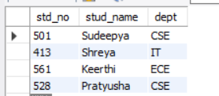

create view stud_details as select std_no, dept from student;

select * from stud_details;

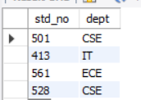

alter view stud_details as select stud_name from student where std_no = 501**;**

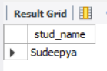

alter view stud_details as select std_no, stud_name from student where dept = "CSE";

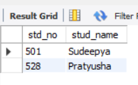

create view stud_view as select stud_name, dept from student where dept = "ECE" with check option;

insert into stud_view values("Sahasra", "ECE");

select * from stud_view;

